Paper 4:
Severity Calculation Results
Table 1: Training Results
Table X: Performance Evaluation of the Proposed DeepLabV3+ with EfficientNet B0 Model
Class Name | Dataset Split | Dice Score | IoU | Accuracy | Precision | Recall | HD95 (pixels)
Corrugation of Rails | Training | 0.8372 | 0.7220 | 0.9734 | 0.8480 | 0.8314 | 59.24
Corrugation of Rails | Validation | 0.7527 | 0.6115 | 0.9648 | 0.6861 | 0.8461 | 78.47
Corrugation of Rails | Test | 0.7732 | 0.6356 | 0.9607 | 0.7717 | 0.7883 | 56.54
Hogging of Rails | Training | 0.8124 | 0.6859 | 0.9808 | 0.8498 | 0.7860 | 64.94
Hogging of Rails | Validation | 0.7890 | 0.6538 | 0.9760 | 0.8027 | 0.7836 | 74.14
Hogging of Rails | Test | 0.7939 | 0.6586 | 0.9786 | 0.7754 | 0.8282 | 86.12
Rail End Batter | Training | 0.7757 | 0.6400 | 0.9867 | 0.8306 | 0.7401 | 54.77
Rail End Batter | Validation | 0.6711 | 0.5250 | 0.9831 | 0.7076 | 0.6788 | 40.14
Rail End Batter | Test | 0.6704 | 0.5233 | 0.9862 | 0.6491 | 0.7006 | 50.57
Rail Wear | Training | 0.7727 | 0.6371 | 0.9667 | 0.8200 | 0.7447 | 100.81
Rail Wear | Validation | 0.7390 | 0.6190 | 0.9422 | 0.6967 | 0.8021 | 102.38
Rail Wear | Test | 0.8272 | 0.7148 | 0.9778 | 0.8392 | 0.8208 | 38.14
Scabbing of Rails | Training | 0.7115 | 0.5636 | 0.9560 | 0.7486 | 0.6945 | 105.76
Scabbing of Rails | Validation | 0.6628 | 0.5062 | 0.9352 | 0.7389 | 0.6315 | 127.50
Scabbing of Rails | Test | 0.7262 | 0.5857 | 0.9597 | 0.7634 | 0.7187 | 75.32
Shelling and Black Spots | Training | 0.8926 | 0.8094 | 0.9499 | 0.9079 | 0.8845 | 79.38
Shelling and Black Spots | Validation | 0.8663 | 0.7699 | 0.9471 | 0.9075 | 0.8332 | 70.48
Shelling and Black Spots | Test | 0.8557 | 0.7510 | 0.9348 | 0.9051 | 0.8192 | 83.26
Wheel Burns | Training | 0.8275 | 0.7084 | 0.9789 | 0.8656 | 0.8020 | 51.08
Wheel Burns | Validation | 0.7501 | 0.6122 | 0.9697 | 0.7894 | 0.7357 | 54.80
Wheel Burns | Test | 0.7678 | 0.6303 | 0.9757 | 0.8811 | 0.6880 | 49.38

Table 2: Run Time Analysis: UNet with Efficient B0 Model

Class Name | Total training time | Avg epoch time
Corrugation of Rails | 517.0809705257416 | 25.85380780696869
Hogging of Rails | 503.3372175693512 | 25.166629004478455
Rail End Batter | 482.4248626232147 | 24.121000051498413
Rail Wear | 2474.3284089565277 | 123.71610946655274
Scabbing of Rails | 801.2330498695374 | 40.06137542724609
Shelling and Black Spots | 1784.948322057724 | 89.24715164899825
Wheel Burns | 760.8759729862213 | 38.04355163574219

Comparative Visualisations of different Defect Types
Defect Type | Real Image | Ground Truth Image | UNet++ (EfficientNet B0) Predicted Image  Severity Value  Action Recommended | UNet Predicted Image  Severity Value  Action Recommended | DeepLabV3+
Rail Wear | 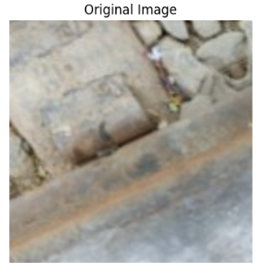 | 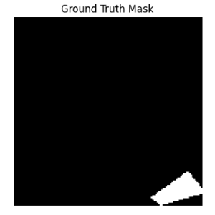 | 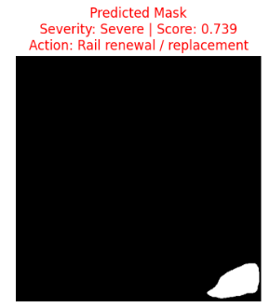 | 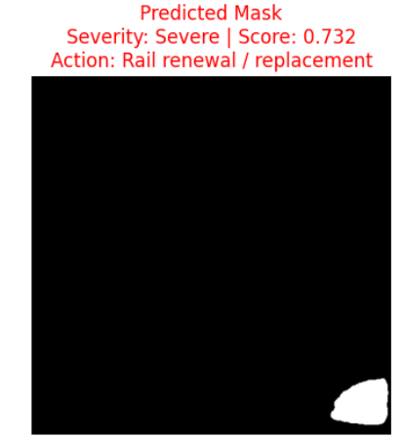 | 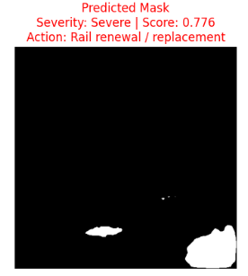
Rail Wear | 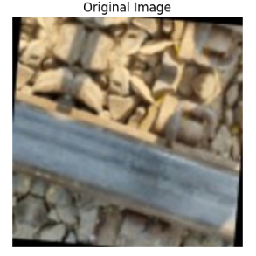 | 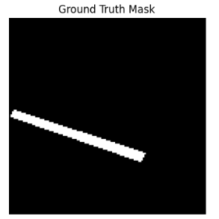 | 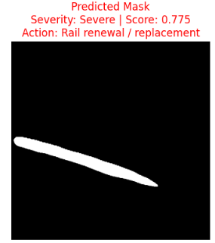 | 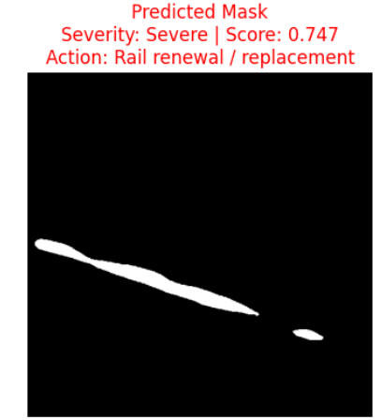 | 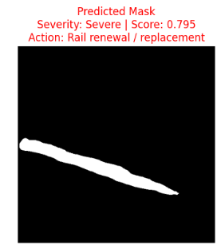
Rail Wear | 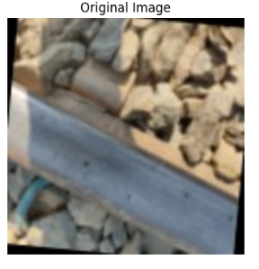 | 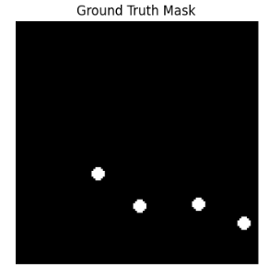 | 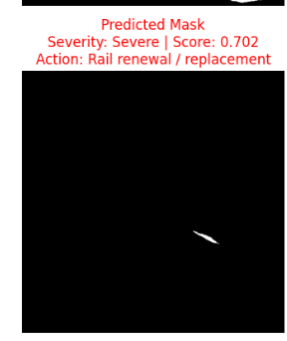 | 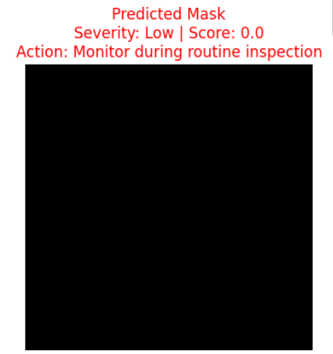 | 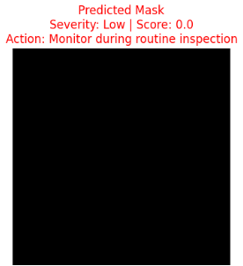
Rail End Batter | 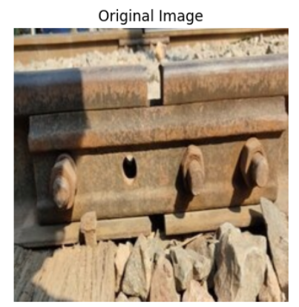 | 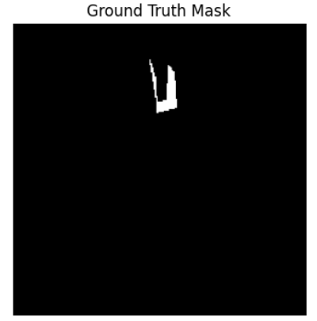 | 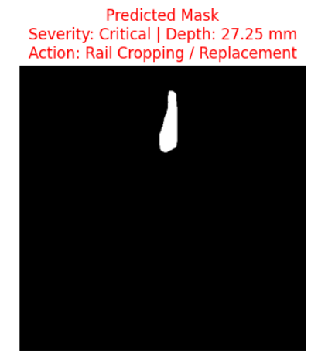 | 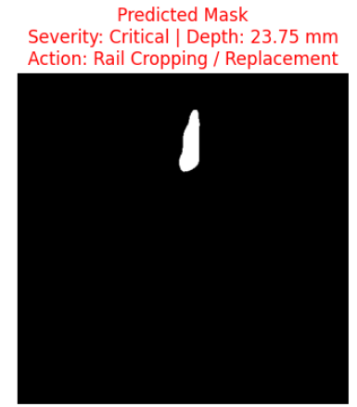 | 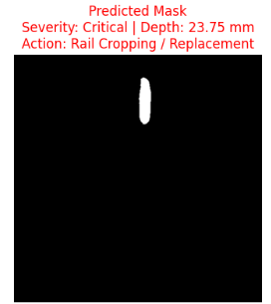
Rail End Batter | 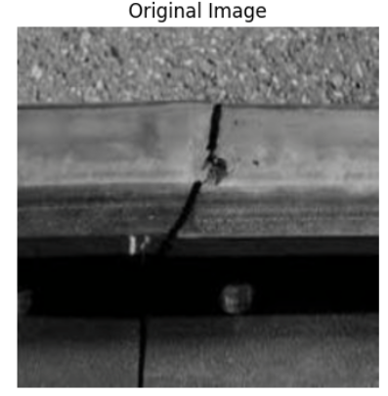 | 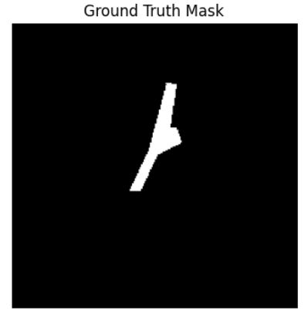 | 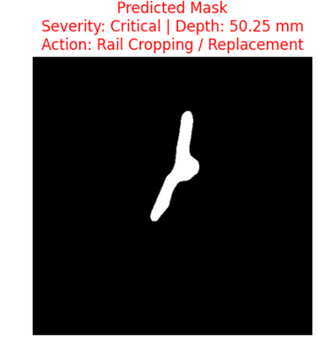 | 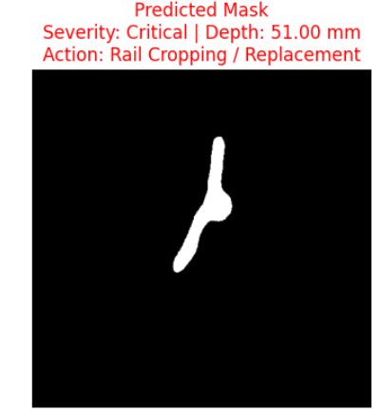 | 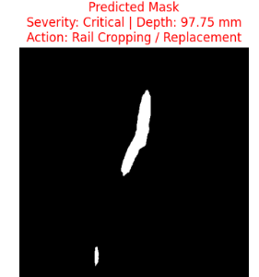
Rail End Batter | 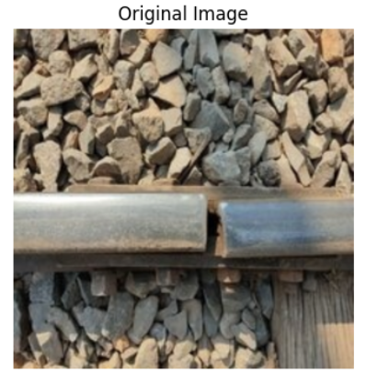 | 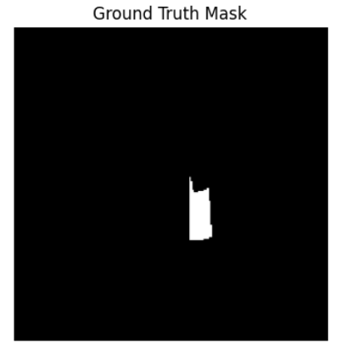 | 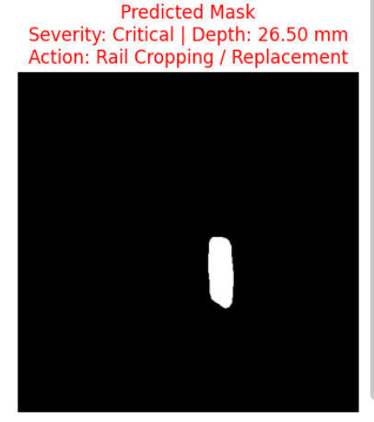 | 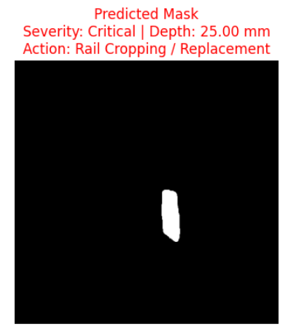 | 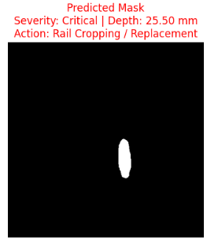

Defect Type | Real Image | Ground Truth Image | UNet++ (EfficientNet B0) Predicted Image  Severity Value  Action Recommended | UNet  Predicted Image  Severity Value  Action Recommended | DeepLabV3+
Hogging of Rails  214  215  217 | 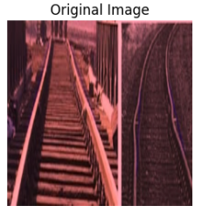 | 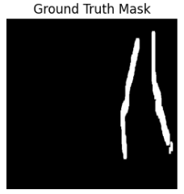 | 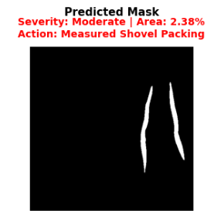 | 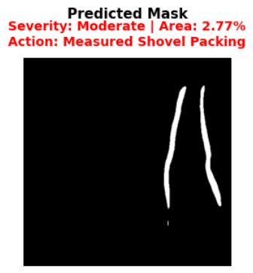 | 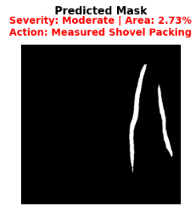
Hogging of Rails  214  215  217 | 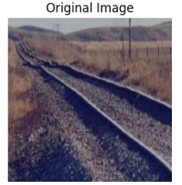 | 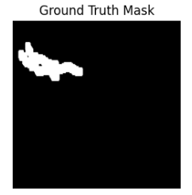 | 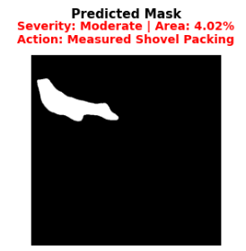 | 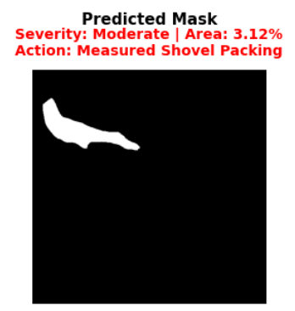 | 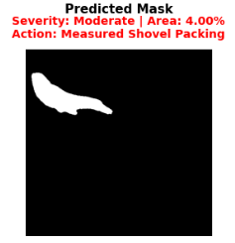
Hogging of Rails  214  215  217 | 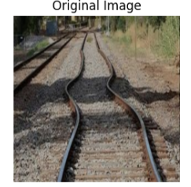 | 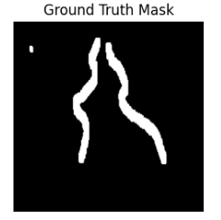 | 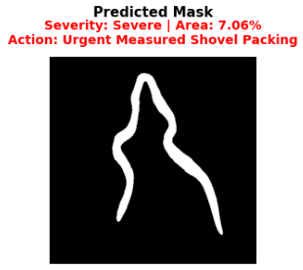 | 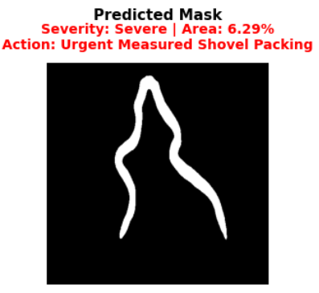 | 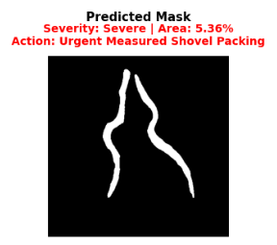
Scabbing of Rails | 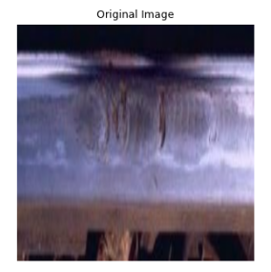 | 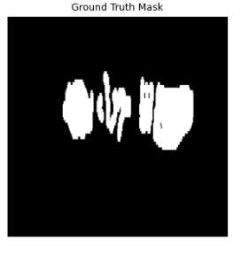 | 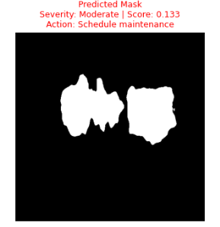 | 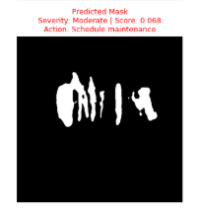 | 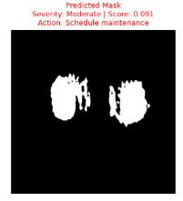
Scabbing of Rails | 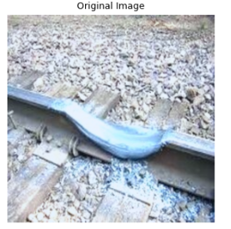 | 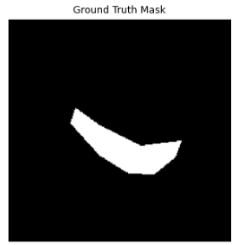 | 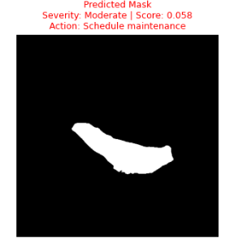 | 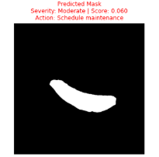 | 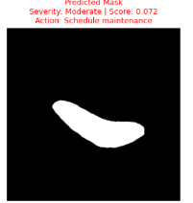
Scabbing of Rails | 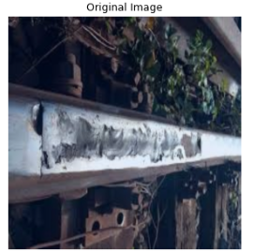 | 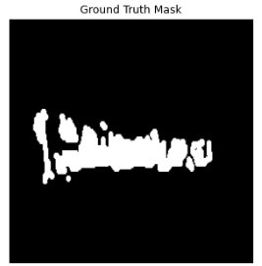 | 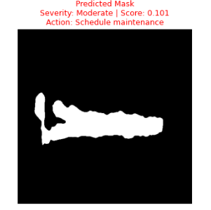 | 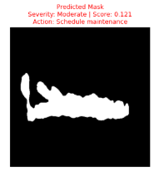 | 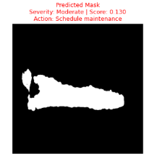

Defect Type | Real Image | Ground Truth Image | UNet++ Predicted Image  Severity Value  Action Recommended | UNet  Predicted Image  Severity Value  Action Recommended | DeepLabV3+
Wheel Burns | 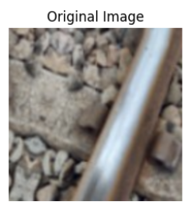 | 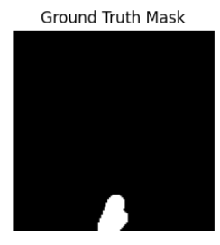 | 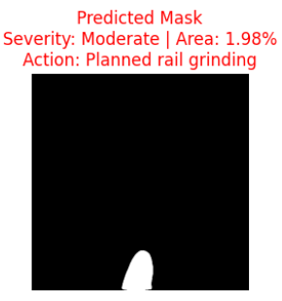 | 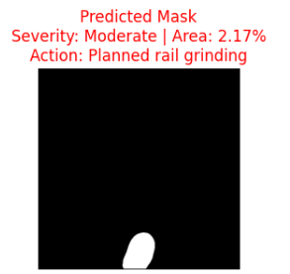 | 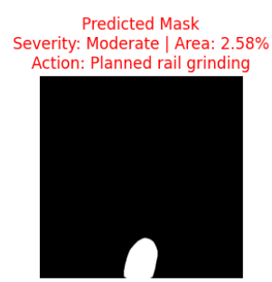
Wheel Burns | 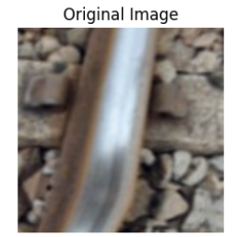 | 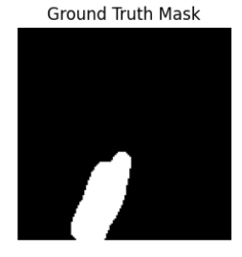 | 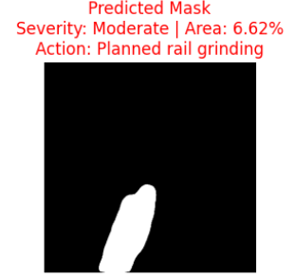 | 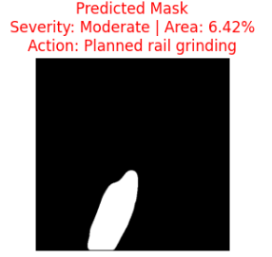 | 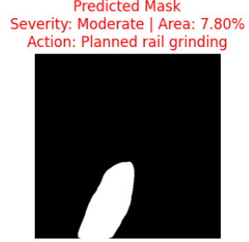
Wheel Burns | 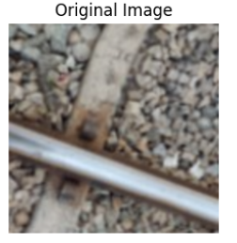 | 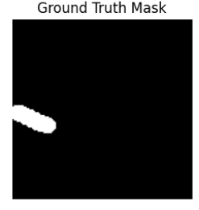 | 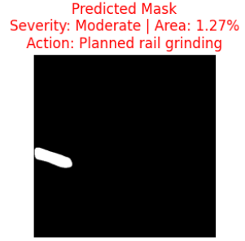 | 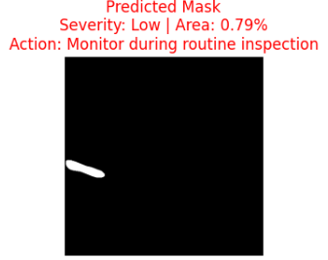 | 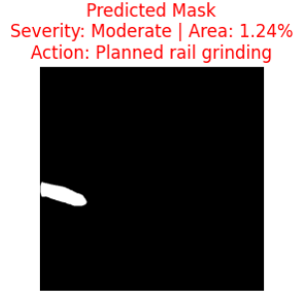
Shelling and Black Spots | 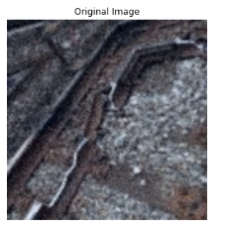 | 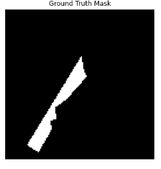 | 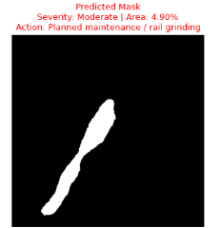 | 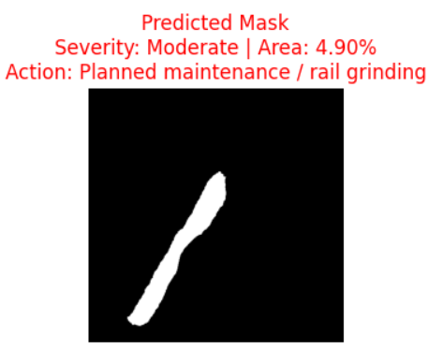 | 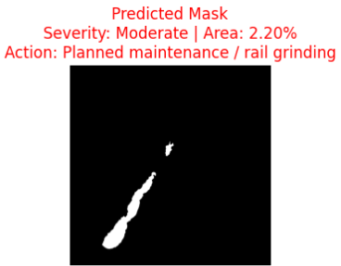
Shelling and Black Spots | 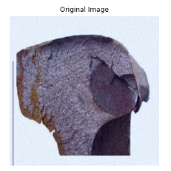 | 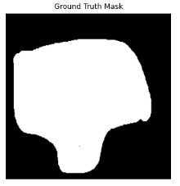 | 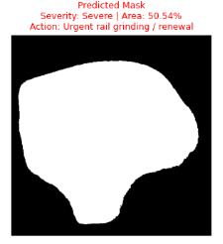 | 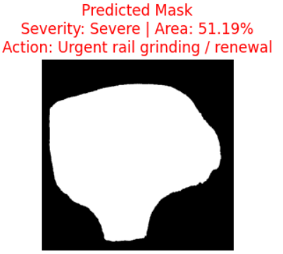 | 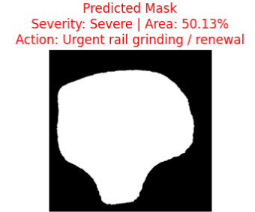
Shelling and Black Spots | 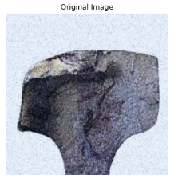 | 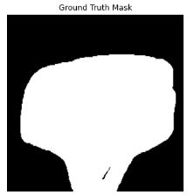 | 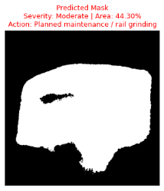 | 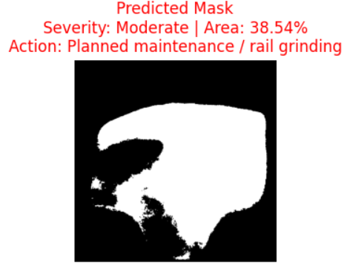 | 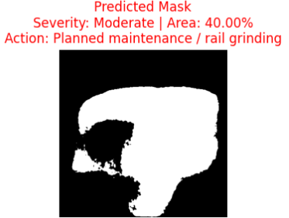

Defect Type | Real Image | Ground Truth Image | UNet++ EficientNet B0 Predicted Image  Severity Score  Action Recommended | UNet Predicted Image  Severity Value  Action Recommended | DeepLabV3+
Corrugation of Rails | 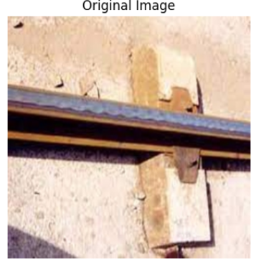 | 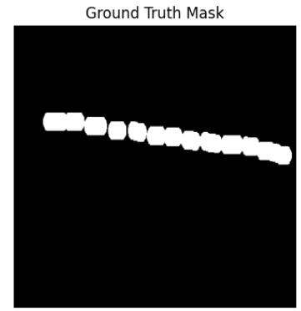 | 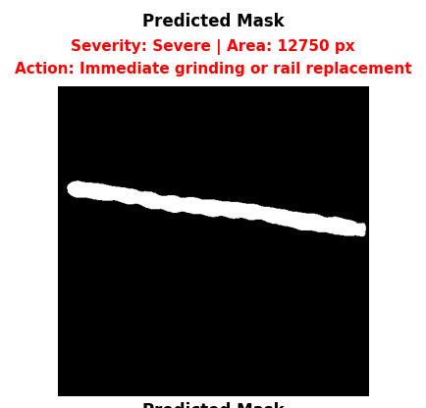 | 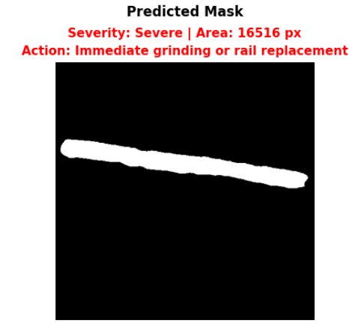 | 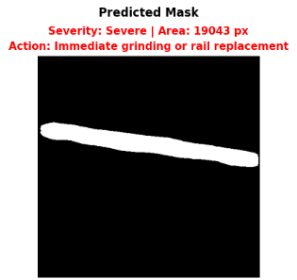
Corrugation of Rails | 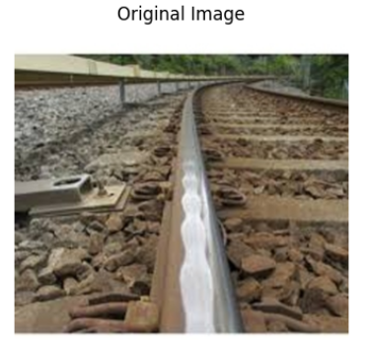 | 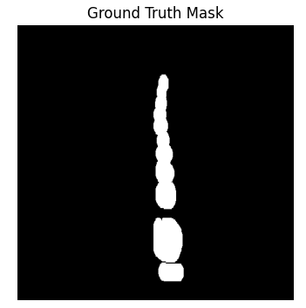 | 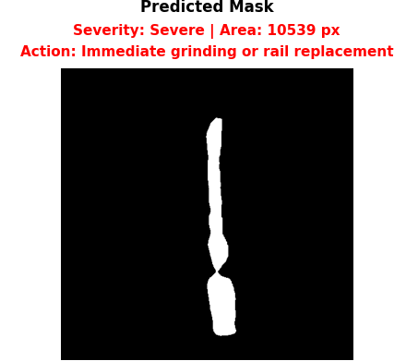 | 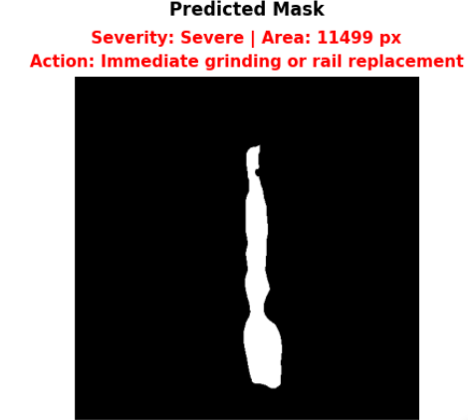 | 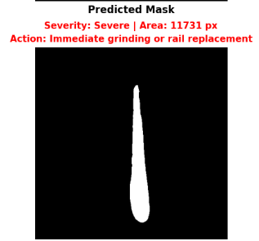
Corrugation of Rails | 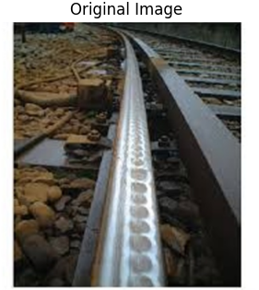 | 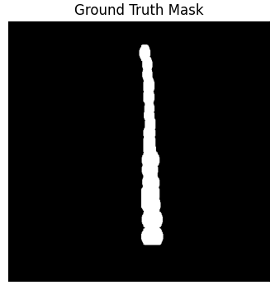 | 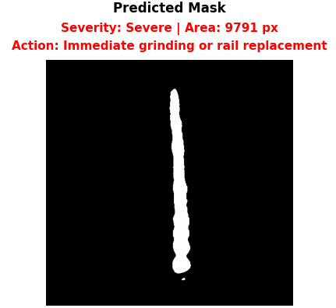 | 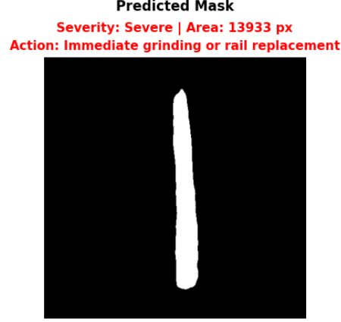 | 

